Application of the Programmable Mode of a Parameter Run

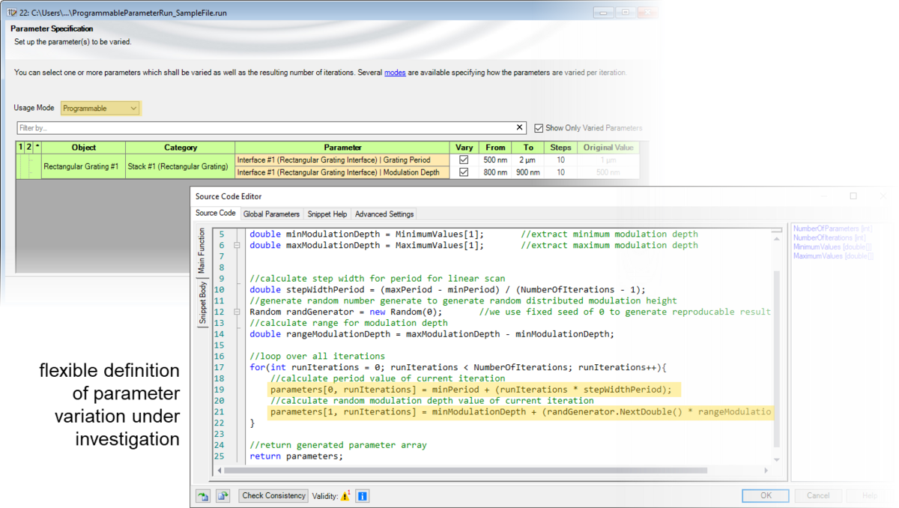
Systematical variations of parameters are substantial for detailed investigations of complex optical systems. VirtualLab Fusion enables the variation of parameters by the so-called parameter run feature. By using the parameter run, such variations can be configured arbitrarily, depending on the demands of the task of analysis. Further, the special programmable mode allows a free configuration in order to provide fully customizable parameter variations. In an example, the application of this programmable mode is presented.

Use Case (PDF)
Use Case and sample files in VirtualLab Fusion (ZIP)

